# Exercises

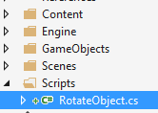

## Rotating Script

1. Create a new Script called **RotateObject**
   1. This script will have a single Vector3 property called **RotationToBeApplied**
2. Every frame you must use **Matrix.CreateRotation** and apply the X, Y and Z value of **RotationToBeApplied** to the **Manager.Owner.World**

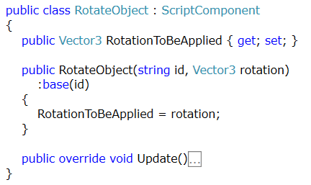

## Bobbing Object Script

1. Create a new Script called **BobbingObject**
   1. This script will make an object bob up and down within a fixed float value on the Y axis
2. Every frame you must use **Matrix.CreateTranslation** and apply a movement on the Y axis
   1. When the object hits the MaxY it must start to move back down
   2. When the object hots the MinY it must start to move back up

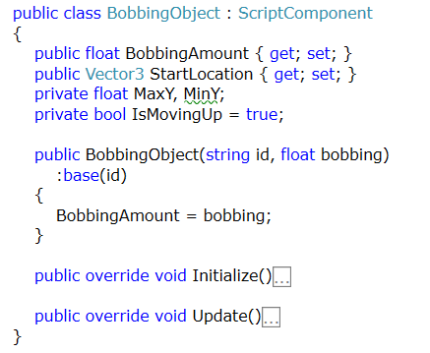

## Move Between Location (WaypointFollowScript)

* Write a script that stores a list of Vector3 locations
* Your script should moves it’s owner between these points continually
  + When the game object reaches a location it should move on to the next location in the list
  + When the last point is reached, the game object should move to the first location

## Additional task

* Extend the previous exercise to:
  + Create a new GameObject called Waypoint
  + Add multiple Waypoint objects to the scene at different locations.
* Update the previous script to find all the Waypoint objects in the scene
  + Add the position of each found waypoint object to list of Vector3 locations